2022

James Caroe

UTC OLP

Unit 3

Table of Contents

LO2 2

Project Plan 2

Folder Structure 3

Hardware and Software 3

Computer 3

Mobile Phone 6

Asset Creation 6

Product Creation 7

LO3 10

Evaluation 10

Final Product Vs Brief 10

Initial Ideas and Planning 10

Choice of Assets 10

Choice of Hardware and Software 10

Strengths 11

Weaknesses 11

Feedback 11

Improvements 11

# LO2

## Project Plan

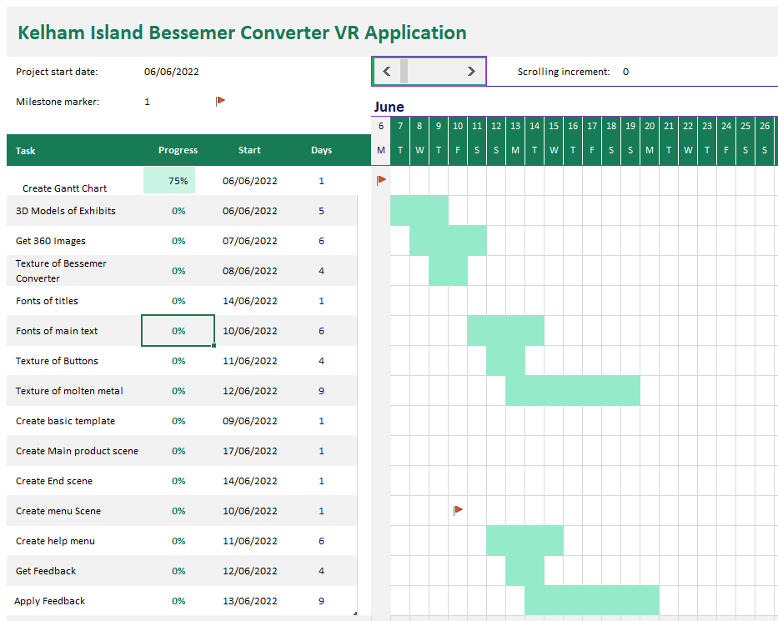

I have made a Gantt Chart to make sure that I can keep track of my work and make sure that I keep on time. One must create a plan because without a plan, one cannot make sure that one is on time with the project. If one doesn’t create a plan, then one can easily run over the deadline.

## Folder Structure

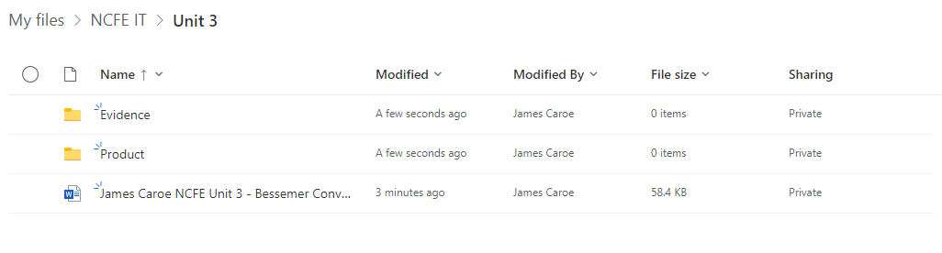

My folder structure is very well organised because it has clearly labelled directories which sort the files into relevant categories. I will make sure that I store all my evidence in the “Evidence” folder, and all the files for my product in my “Product” folder. This is so I will be able to find my files easily.

It is important to organise one’s work because it helps one find the files that one desires. If one does not organise one’s work, then it becomes very hard for one to keep track of one’s files.

## Hardware and Software

### Computer

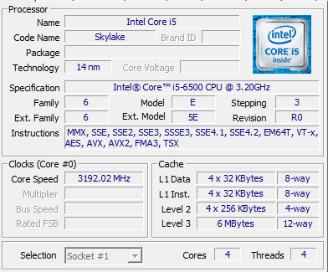

My computer that I used in school isn’t a very powerful computer, and so won’t be very good for the creation of a VR application. One needs a machine that is powerful enough for what one wants to accomplish. My PC has 4 cores, 4 threads, and has an Intel Core i5.

#### Unity

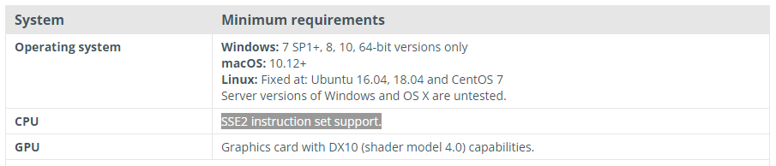

These are the minimum requirements for development in Unity – the game I will be developing my product in. The PCs that I will be using has windows 10 64-bit version and supports SSE2. This is in line with the minimum requirements for development in unity. The GPU on the PCs I will be using is the Intel HD Graphics 530. This is not quite up to specifications, but it will manage to run unity, just a bit slower.

I would ideally need a Graphics card with DX10 capabilities; however, I don’t think that this is not going to be possible. I have 16GB of RAM, which is enough to use Unity. This will make sure that Unity won’t crash when I run it.

The machine that I will be using will be just under requirements on some areas, but it won’t matter too much because it will still be able to run Unity.

#### Blender

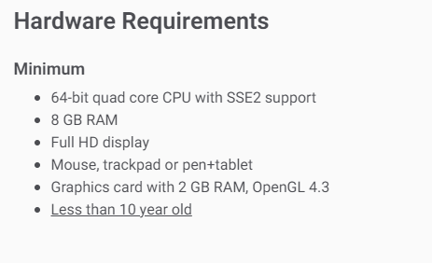

These are the minimum requirements for blender. The computer that I will be using meets these requirements.

* The CPU is 64-bit quad core, with SSE2 support, this means that it will be able to handle the requests of Blender.
* I have 16GB of RAM, which means that it will be able to store the files of Blender whilst it’s running.
* The monitor that I will be using is an HD monitor with a resolution of 1920x1080 which is more than enough run blender
* I have a mouse that has all the functions needed.
* My PC is less than 10 years old
* My GPU supports OpenGL 4.3 however it doesn’t have any RAM and just uses the computer’s normal RAM, so it won’t be able to show the graphics properly

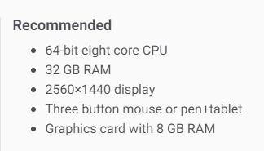

These are the recommended specifications for Blender, I have compared them to my specifications below:

* My CPU is 64-bit however it is not eight core which means that it won’t have as much processing power as is needed. It will still run; however, it will be much slower.
* I only have 16GB of RAM. This is half the recommended amount, which means that it won’t be able to store all the files needed. Blender can still function with 16GB of RAM but won’t be as fast.
* My display is only 1920x1080 which is not as high resolution as recommended by Blender, this means that I won’t be able to see all the details when making 3D models.
* I have a three-button mouse which means that I will be able to have full functionality of Blender
* My Graphics card has no RAM. This means that the graphics will not be very good at all, but it will still function at a very slow rate.

### Mobile Phone

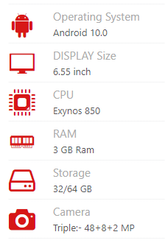

These are the specifications of my mobile phone. I will use my mobile phone to take pictures of textures to use in my product. The camera installed is more than adequate with a 48MP lens which will capture any texture in detail.

I will also use my phone to record sounds for my product, I wasn’t able to find the microphone specifications for my phone, but from experience I think it will be good enough to capture audio for my product.

My phone has 32GB of storage, this is plenty to take photos of textures and audio recordings for my product.

I will not be using my phone for the creation of any other parts of my product, so the specifications do not have to be very good.

## Asset Creation

|  |  |
| --- | --- |
|  | I have added a texture to my model, this makes the model look more realistic and better. I choose the repeat option to try and make the texture look like it doesn’t end and have a border. This is better than the extend option which just copies the edge pixels of the texture. This wouldn’t look very good because there would be notable edges of the texture. |
|  | I added an array modifier to my rivets. This makes copies of the rivets all the way around the model.  This saves me a lot of work because it means that I don’t have to make them individually. It also means that they are more regular, and every rivet is positioned properly.  I set the array modifier to follow a BezierCircle so that it is perfectly round and not misshaped in any way. |
|  | I chose a font for my titles of the product. This will be on the main menu screen. I chose this font because it is easy to read and has a nice feel to it. I have downloaded the font for this. |
|  | I have made a rough design of what my text will look like. This is an image of what it will be like, just with sample placeholder text.  I chose this font - Myriad Pro – because it is very easy to read and is clear. |
|  | I have bevelled my text to make it look more visually appealing. I made the colours a gradient from orange to red. This reflects on the fire in the forging of steal in the steal works. |
|  |  |
|  |  |

## Product Creation

|  |  |
| --- | --- |
|  |  |
|  | I created a button that allows the user to start a process within the product. This increases interactivity and engagement in the product – encouraging the user to stay using the product. |
|  | This is the code I used to create the interactivity. It detects when the user presses a button and then starts some code that tips the model of a Bessemer Converter. |
|  | This is the code that I used that tips the Bessemer converter at the press of the button from the user. It detects which way the converter is tipping and keeps tipping it accordingly or switching it’s direction when needed. |
|  | I used an array modifier to make the creation of my Bessemer converter model easier. This allowed me to duplicate 3d objects without needing to manually create them myself. Blender did the maths and created duplicates of my models for me. |
|  | I applied the array modifier which meant that all the changes that I made with the modifier were made permanent. |
|  | I saved the 3D models as .fbx file because this filetype is widely used for 3D models in games and applications. I changed the filetype from .blend files so that they were compatible with more applications. |
|  | I have saved all my assets in my assets directory so that they are easily accessible and easy to find. I have scripts, objects, and materials. |
|  | I created multiple tubes for my “molten metal” to sit in. I went through multiple objects trying to get a model that worked with satisfactory results. |
|  | I named my files names that describes what exactly they are. For example: I called one of my models “lowlodtube.fbx” LOD stands for “Level of Detail.” This file is a low level of detail tube as shown by the name of the file. |
|  | I exported my project as a .apk file to load it onto a Meta Quest 2. This allows it to be installed as an application on the Quest. I have changed some settings to allow for better performance on the Quest. |

# LO3

## Evaluation

### Final Product Vs Brief

My final product meets the brief from Kelham Island – To create an interactive product to enhance visitor’s experience at the museum – quite well. I have made a virtual reality (VR) application to run on a Meta Quest (formerly called Oculus Quest). I have interactivity in the form of buttons that perform different actions. Some buttons show information about the Bessemer Converter, one triggers an action that tips the Bessemer Converter to give the user a sense of what it would look like in action, another resets the scene. The added information allows the user to learn more about the Bessemer Converter, and the VR application makes the information more interesting and interactive for the user rather than reading from static information boards.

### Initial Ideas and Planning

My final product differs a lot from my initial ideas for my product. I initially set out to create an augmented reality (AR) application for the museum. However, I decided to not make an AR application because putting the essential markers around a museum would spoil the atmosphere. I decided to create a VR application because they are very engaging and interactive for the user and my school has the resources to create a VR application.

### Choice of Assets

I used quite good assets that I created all myself. I created my 3D objects in Blender and exported them into Unity using .fbx files. I created my 3D objects myself because I wanted them to be realistic. I created the materials that I used in Unity itself. My materials could’ve been a bit more authentic because my metal texture is not entirely realistic as is my molten metal texture.

### Choice of Hardware and Software

I chose to create my VR application to run on a Meta Quest 2 because they are the VR headsets that my school has, and they are very portable, freestanding headsets. They don’t need a computer to run off, they are essentially an android device. They are also relatively inexpensive which is good for a museum that does not charge an entrance fee.

I created my VR application in Unity, a multiplatform game and software development software that is free to use for non-profit uses. This was a very good choice because it was relatively simple to create my application and it will be supported very widely because Unity can export to .apk files which are used to install applications on android devices. I used Unity on a Windows 10 desktop PC to get good performance. If I had used a less powerful device, it would’ve been hard to create my product.

### Strengths

Some of the strengths of my product include:

* It is quite intuitive because it has big obvious buttons that can be pressed with labels showing what the buttons do. It should be quite easy for most demographics to use.
* It is not a very big project. The .apk file is only 82MB, not very big for a VR application. This means that it doesn’t need a particularly high specification machine to run it.
* It is not very expensive for a VR application because it doesn’t need a high spec headset to run it

### Weaknesses

Some of the weaknesses of my product include:

* It is quite expensive for an interactive product as it requires a VR headset
* There is only information about one specific exhibit, there could be more features and information covering other exhibits.
* It only works on a Meta Quest; it won’t work on other VR headsets because it has been built for the Quest.

### Feedback

Negative peer feedback:

* It can be quite hard to press buttons for inexperienced users. Perhaps could improve the collision detection?
* Some of the textures could be more detailed

Positive peer feedback:

* The model of the Bessemer Converter is very detailed and looks very good.
* The molten metal affect is very effective
* The button pressing system is very simple to use (when the user uses it correctly) and is very intuitive
* There is an easy method to reset the application
* The product is nice and interactive, it will be very good in a museum

### Improvements

My product was very good overall, there were a few improvements that could’ve been made.

* I could’ve added more interactivity for the user. There is some interactivity but to make a museum exhibit more interesting there needs to be a lot of interesting things to do, which my product only has some of.
* I could’ve used more accurate and detailed textures for my models which would’ve improved the feel of the product overall.
* I could’ve used a better representation of lava for my bessemer converter to tip out. I only used spheres which is a bit basic.
* My information board only shows text, I could’ve added some images and potentially a video in to make my product more engaging for the user.